M NAGESH

1.1 Login to the Client PC as **lab-user**

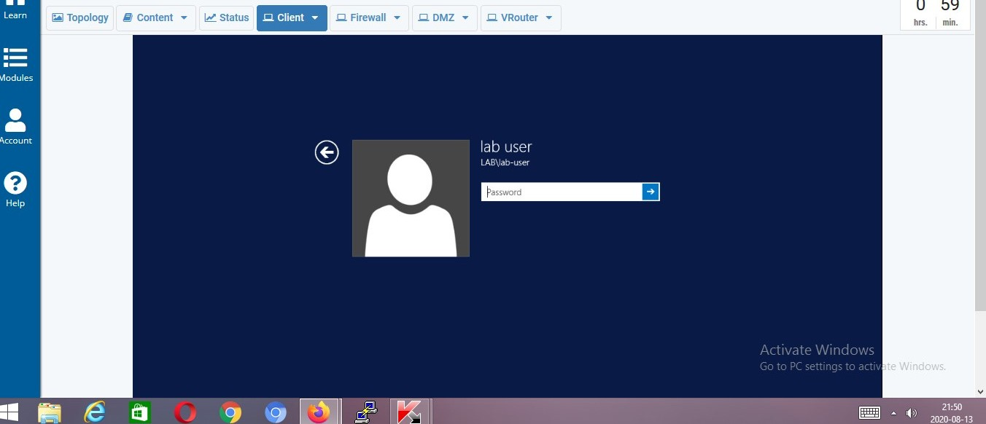

1.2. In the Google Chrome address field type https://192.168.1.254 and press enter.

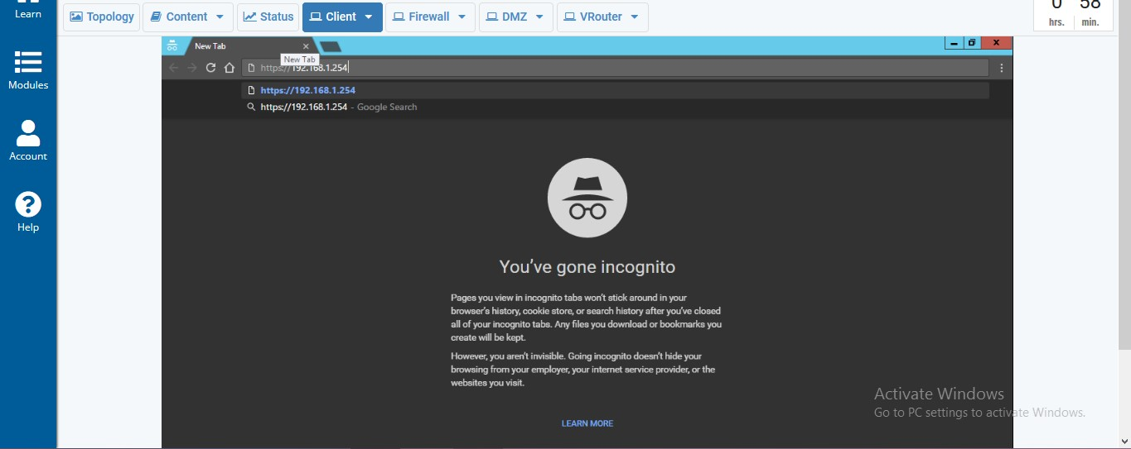

1.3. Login to the firewall web interface.

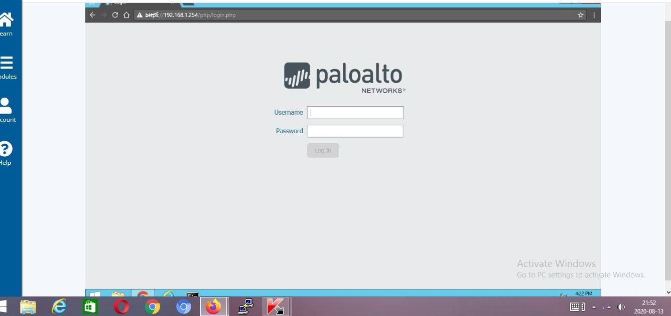

From the firewall web interface, **load the named configuration snapshot 210-gateway-lab-04** and click **OK**.

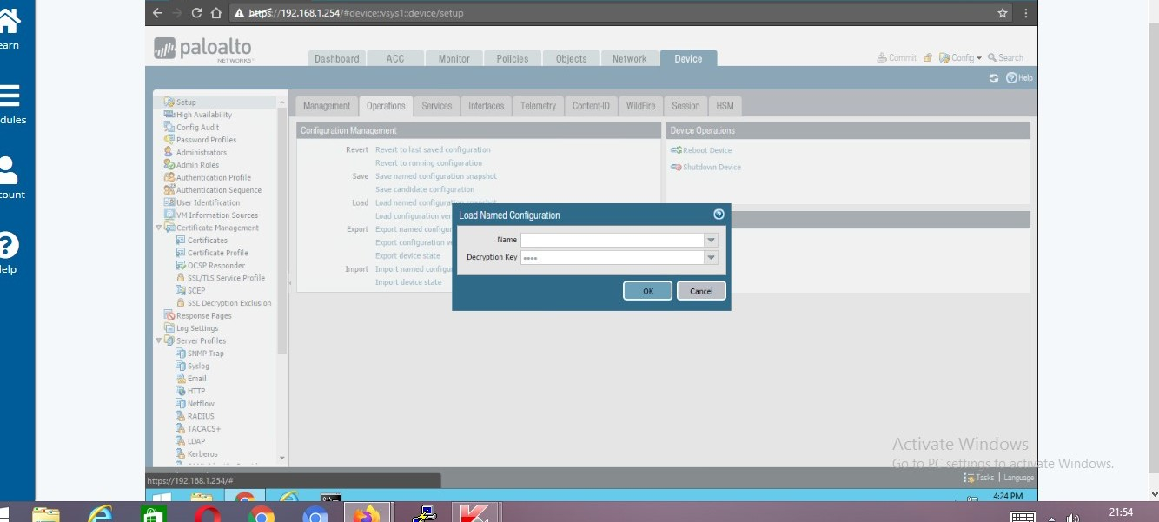

Create a Wireshark Packet Capture

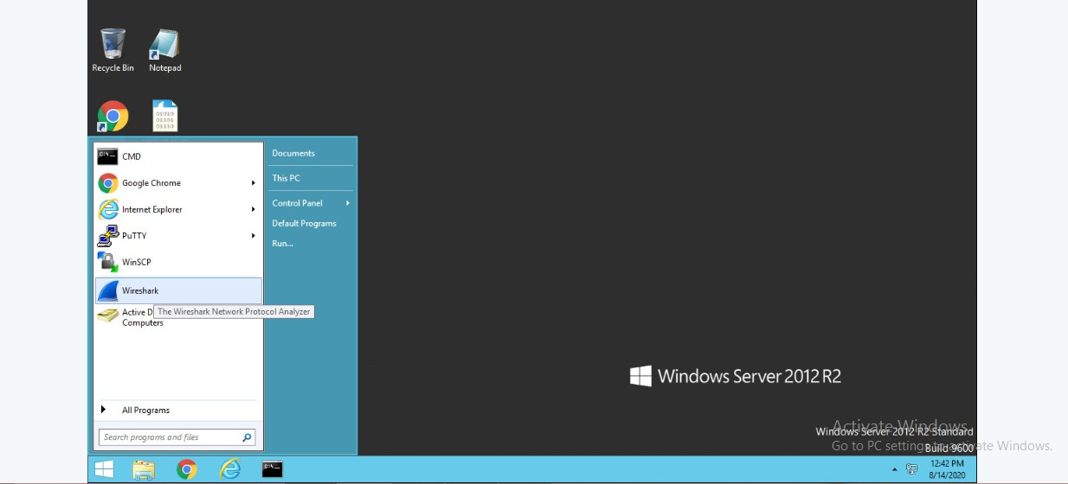

Click on the **internal** interface from the list.

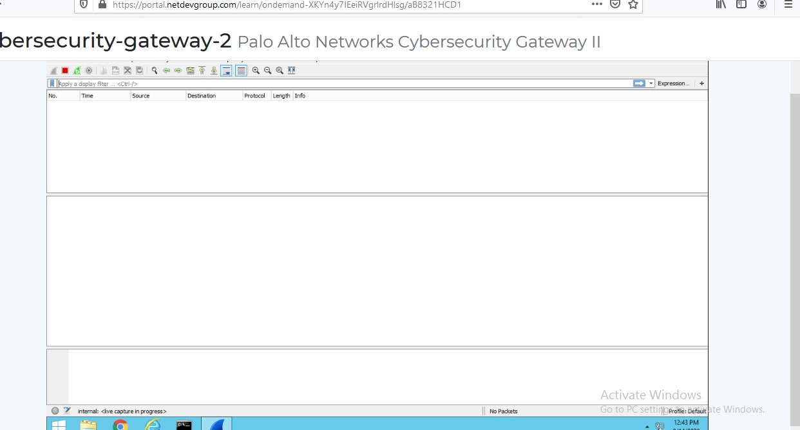

Click on **Capture** > **Start**

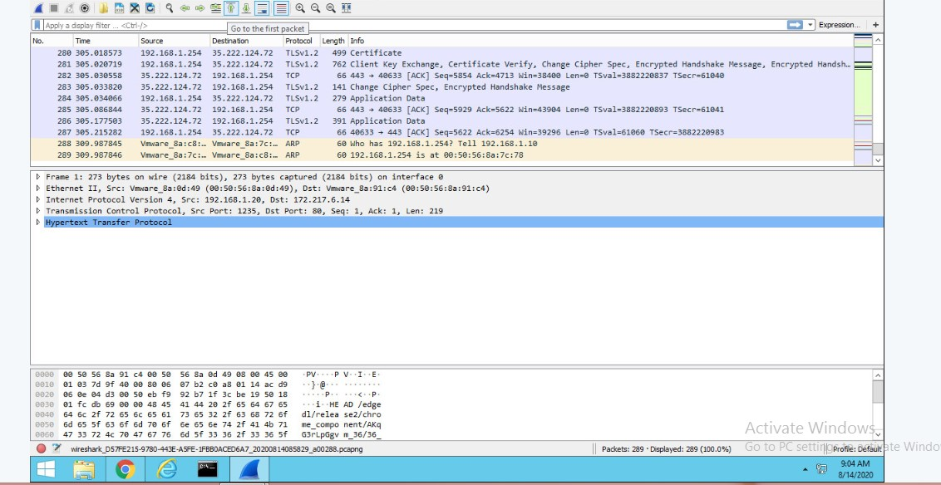

Open a **new tab** in Chrome Web Browser > type **www.google.com** > click **Enter**.

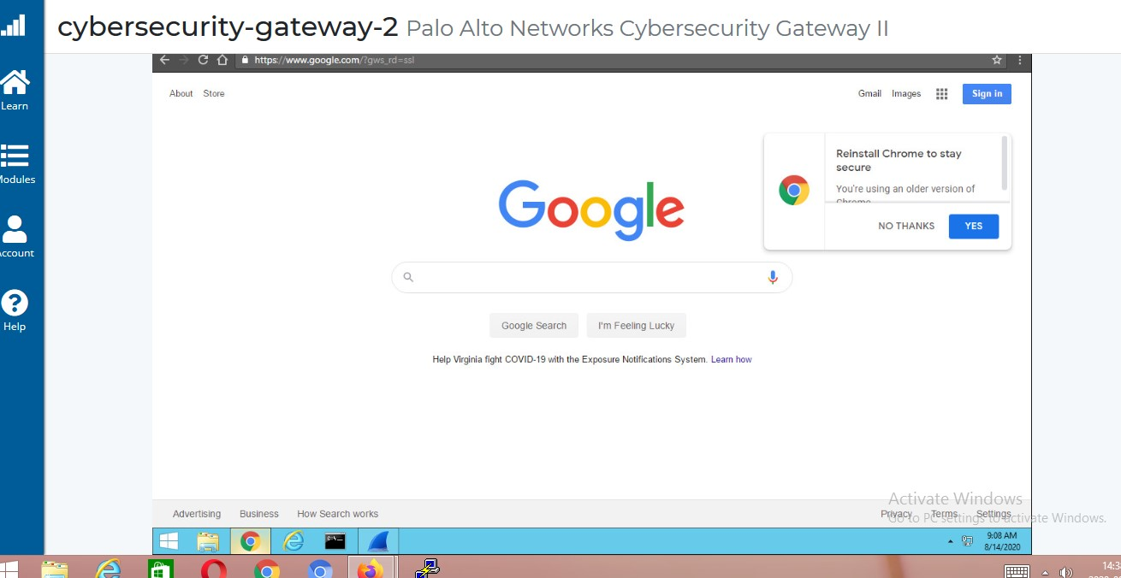

Wait 5 to 10 seconds and reopen **Wireshark** > Click the **Stop Capture** Button

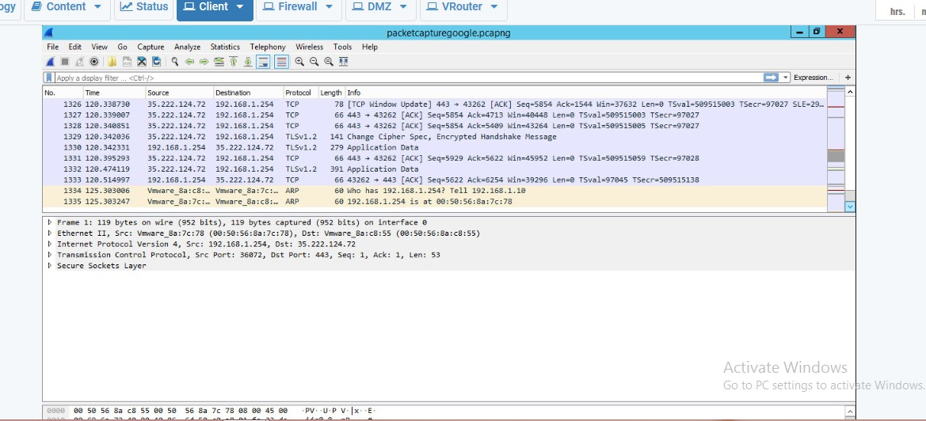

While examining the Wireshark Packet Capture, notice the **ARP**, **DNS**, **TCP and HTTP** Protocols and provide a screen shot here:

ARP

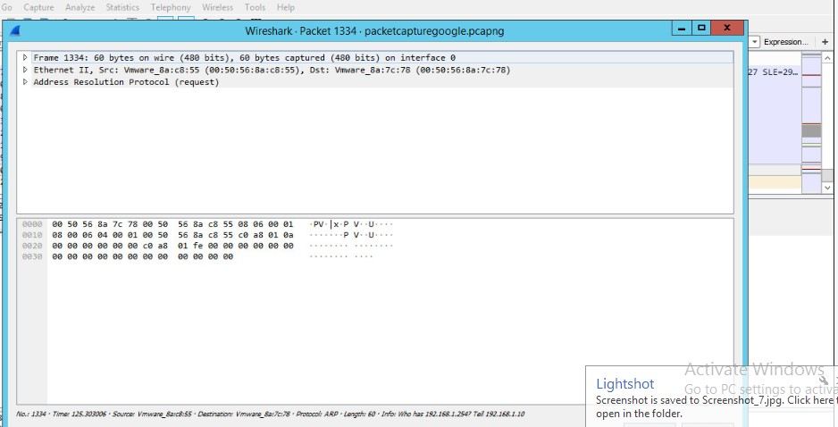

DNS

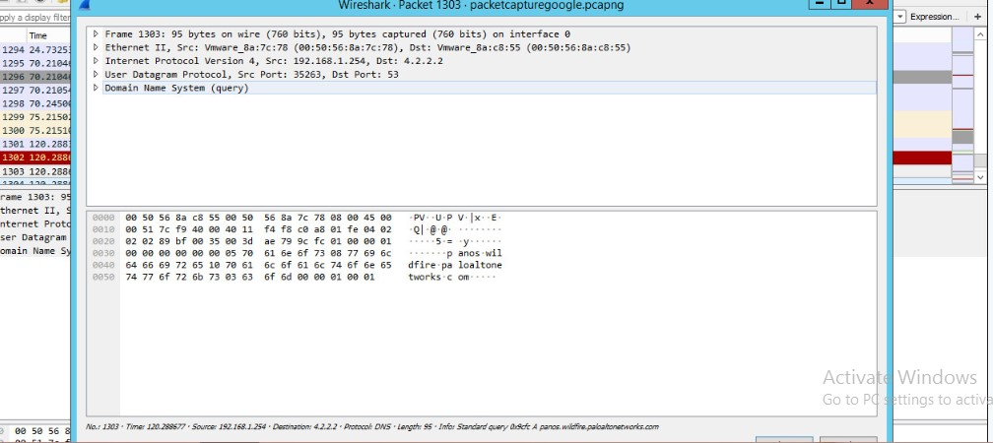

TCP

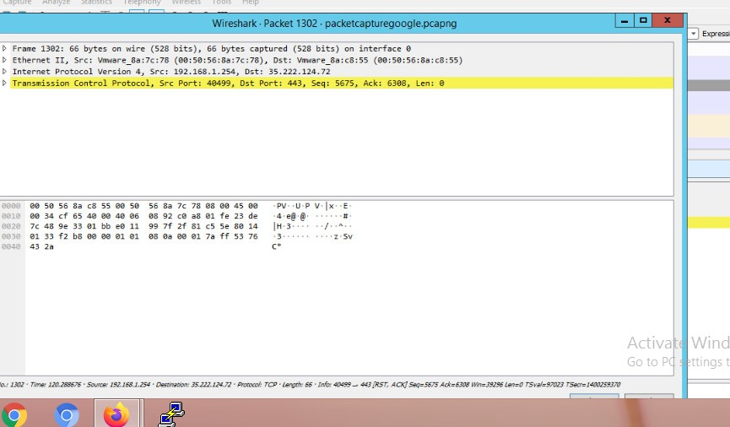

* What function does ARP perform?

The **Address Resolution Protocol** (ARP) is a communication protocol used for discovering the link layer address, such as a MAC address, associated with a given internet layer address, typically an IPv4 address.

* What is the purpose of DNS?

The **Domain Name System** (DNS) is the phonebook of the Internet. Humans access information online through domain names, like nytimes.com or espn.com. Web browser interact through Internet Protocol (IP) addresses. DNS translates domain names to IP addresses so browsers can load Internet resources.

* Explain how TCP works?

TCP/IP stands for **Transmission Control Protocol**/Internet Protocol. TCP/IP is a set of standardized rules that allow computers to communicate on a network such as the internet.

* What is the purpose of HTTP?

Hypertext Transfer Protocol (HTTP) is an application-layer protocol for transmitting hypermedia documents, such as HTML. It was designed for communication between web browsers and web servers, but it can also be used for other purposes.